AI Solution Architecture
Team: Karissa Kocourek and Daniel Escalante
Deadline: Wednesday, September 30 at 11:59 PM
Submission: Canvas (one submission per group)
In the previous milestone, your team described in general terms how AI can address a specific problem in biomedical and health sciences. Now you will design the overall architecture of how your AI system will work, outlining the major components of the system and developing a plan for how information will flow between them.
This assignment is focused on visualizing how your final AI system will work, not how it will be built. For this exercise, assume that all AI functionality is feasible, and imagine that your system has already been deployed in its intended real-world setting. Do not include any details about system development, including model training, fine-tuning, evaluation, or any other steps involved in creating the system. We’ll focus on those in an upcoming milestone.
Instead, this milestone is about breaking down the solution-oriented objective from your AI Sketch into one or more concrete AI tasks involved in the execution of your system for a single run. Designing how your final system will work and identifying the specific AI functionality required by your system is a crucial first step which will guide your resulting technical development.

1. AI Design Project Update (2-3 sentences)
Provide a brief overall update on your project since the last milestone submission. Note anything that has changed in the problem or direction. Changes do not need to be justified. If nothing has changed, feel free to leave this blank.
AI Design Project Update:
Since Milestone 1, Karissa's experience at the bench shifted our focus from specimens that degrade during ordinary delay to specimens that are lost or stalled, because stability windows run from 24 hours to 7 days while transport takes minutes to hours. The stability clock runs from collection to plating. We also found that the unobserved interval includes the time a specimen waits on the laboratory counter before it is received.

2. AI System Objective (1-2 sentences)
Summarize your AI system’s overall objective and how it directly addresses the gap you identified in the previous milestone.
AI System Objective:
Tracer detects specimens that are lost or stalled between collection and plating early, estimates where each one most likely is, and directs the right person to it before recollection becomes necessary. It closes the gap identified in Milestone 1, where the interval between collection and receipt is unobserved and a specimen that never arrives produces no signal until someone notices it is missing.

3. Form Factor (2-4 sentences)
Describe what your hypothetical AI system looks like after it “goes live” in the real-world. What form does it take (e.g., web or mobile application, plugin, server, dashboard, agent, model(s), etc.)?
Form Factor:
Tracer is a background service that continuously reads specimen events from the laboratory information system and carrier events from the pneumatic tube system. It displays a live board at the specimen receiving area that ranks every outstanding specimen by urgency. It sends alerts directly to the receiving tech’s workstation. It also keeps a timeline view for each specimen that shows every scan, the time spent on each leg, and where the specimen most likely is now.

4. User Interaction (2-4 sentences)
Who are the users of your AI system, and how does your system interface with them? For example, your system might require direct user input, deliver results directly to users, both, neither, or anything in between. Your system could be an interactive tool that a user decides to open and use, or it could run in the background with specific triggers and usage criteria.
User Interaction:
The primary users are the receiving and plating assistants and techs, who are usually the first to notice a missing specimen today, with supervisors as the escalation tier and collecting units contacted when a specimen was never sent. Tracer runs in the background on every specimen and requires no input to start. When a specimen needs attention, it delivers an alert with a short search brief to the receiving tech and posts it to the live board. The tech then records where the specimen was found or that it was not found, which closes the alert.

5. AI System Context (4-6 sentences)
First, describe the real-world context leading up to how your AI system would be used given current practice and status quo. Would your hypothetical AI system be used 100% of the time or only in certain situations? If it requires a conscious decision to use, what factors affect the decision-making? Then, describe the similar real-world context after your hypothetical system is used. What does your system produce or accomplish? How does it change current practice or the status quo?
Context before using AI system:
Today a missing specimen produces no signal, so it is noticed late and indirectly. Staff search for it by hand, escalate to a supervisor after several failed attempts, and, if the specimen is declared lost, trigger a hospital-wide lost-specimen alert that requires every department to search its area and empty stored pneumatic tubes.
Context after using AI system:
Tracer flags an abnormally long dwell on a specific leg within minutes to hours, names the most likely location, and gives the time left before recollection would be required. Searches become targeted, most losses are resolved before a hospital-wide alert would be needed, and fewer patients need to be recollected. It runs on every specimen all the time, so no decision is needed to use it.

6. System I/O (3-6 sentences)
Think about your proposed AI system as a black box whose overall purpose and function is clear, but its inner workings are not. For a single, hypothetical run of your final system, describe the information that goes into the black box system (input data) and the information that comes out (output data). Where does the input data come from? Where does the output go and/or how is it used after leaving your system?
Overall System Input:
A single run is one assessment of one specimen at one moment, triggered by a new scan or pneumatic tube event, or by a periodic check while the specimen is between scans. Each run takes the specimen type and the tests ordered, since an anaerobic culture shortens the window, together with the collection time and every later scan timestamp from the laboratory information system. It also takes carrier dispatch and arrival events from the pneumatic tube system, the current time, and the current receiving volume in the lab.
Overall System Output:
The run returns the specimen’s status, its most likely location with ranked alternatives, the expected time of its next scan, and the time remaining before recollection would be required, all of which update the live board and the specimen’s timeline. When warranted, it also sends a prioritized alert with a short search brief to the receiving tech’s workstation and the live board, and the outcome the tech records is logged with that alert.

7. AI Modules (1-4 modules)
The overall goal of your AI system is to transform input to output data. Most AI systems can be broken down into a sequence of distinct steps, stages, or modules. In many cases, an AI system or tool involves several distinct AI functions beneath the surface which work together to achieve the overall system capability. Non-AI modules are also common (e.g., data processing and transmission, retrieval and lookup, rule-based execution flow based on outputs of other AI modules, etc.).
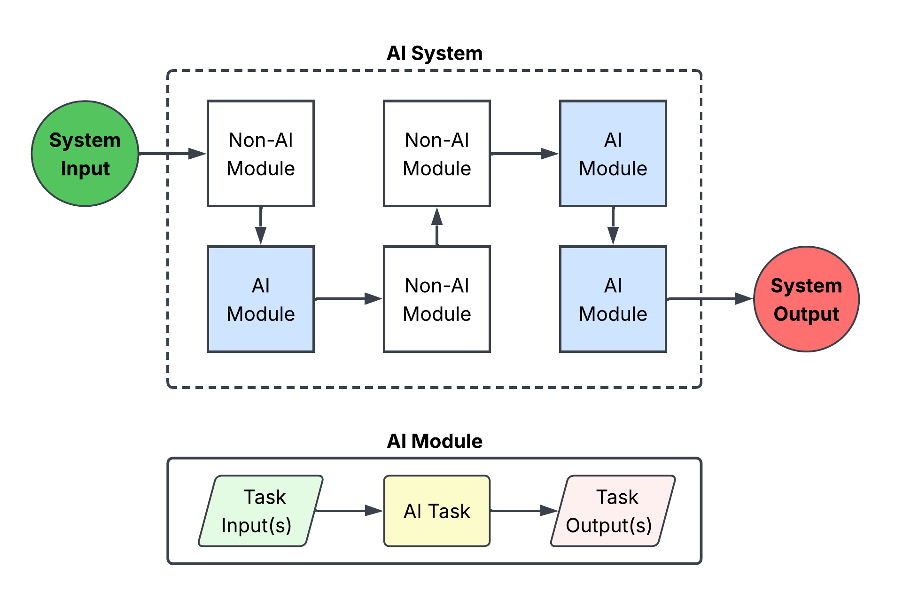
Example of a high-level modular AI system architecture for a single run. Information flows from overall system input (e.g., what a user provides) to overall system output (e.g., what the system gives back to the user) through a path of both AI and non-AI modules. Each AI module centers around a specific, well-established AI task.
In this section, we’ll focus exclusively on the core AI modules of your hypothetical system. You can think of each distinct AI module as its own small-scale black box system which uses a specific AI function (or AI task) to transform the module input (which might come from the output of other modules) to module output, which might then be routed to the input of other system modules. An AI task often uses a specific type of underlying machine learning model.
AI Task
Examples: Predict, extract, summarize, recommend, generate, etc.
Task Output
Examples: Probability of X, extracted text excerpt, summary of documents, etc.
Task Input
Examples: Patient profile, medical image, clinical note, user question, etc.

Example AI module. Includes input data, AI task, and output data. AI systems often use several distinct AI modules.

Think about what is necessary to enable the overall system to work as intended, and whether the overall objective can be broken down into smaller objectives that can be mapped to existing, established AI tasks (which often have clear best practices and technical methods).
For now, don’t worry how these AI modules will be implemented. Instead, focus on identifying one or more AI tasks your system will use, and specifying the input and output to each to characterize your system’s AI modules. We will also ignore non-AI modules for the time being.
Examples of common AI tasks are shown in the table below.

AI Task | Description | Example
Text Classification | Assign an overall label to an entire piece of text. | Categorize a patient message as related to refill requests, scheduling, new symptoms, or billing.
Named Entity Recognition | Find, label, and/or extract specific words or phrases in text. | Extract medication names, doses, frequencies, side effects, etc. from a discharge summary.
Zero-Shot Classification | Assign dynamic labels to input data without training examples, often with an on-the-fly guiding prompt. | Sort wound photographs into flexible categories based on patient history.
Question Answering | Answer a question using information contained in text . | Identify specific patient history events from longitudinal patient notes.
Document Visual Question Answering | Answer questions posed about digitized text and other documents. | Read a scanned insurance form and report what was authorized.
Sentence Similarity | Determine how similar two pieces of text are in meaning. | Rank volumes of clinical guidelines based on relevant to the current patient.
Summarization | Condense longer text into a shorter version. | Distill all patient progress notes into a single paragraph.
Translation | Convert text from one language into another. | Translate patient discharge instructions from English into Spanish.
Text-to-Text Generation | Write new text in response to a prompt or input. | Draft a prior authorization letter or response to patient message.
Tabular Classification | Assign a label to spreadsheet-like data. | Predict whether a patient will be readmitted to the hospital in the next 30 days.
Tabular Regression | Predict a continuous number from spreadsheet-like data. | Predict a patient’s length of stay in days.
Time Series Forecasting | Predict future values of a sequence measured over time. | Predict serum creatinine trajectory from repeated laboratory measurements.
Image Classification | Assign a label to an image. | Predict whether a skin lesion photo is benign or malignant.
Object Detection | Locate distinct, unique entities in an image or video. | Count the number of cells in a microscopy image.
Image Segmentation | Divide an image into labeled regions. | Identify a brain region from fMRI.
Image-to-Text Generation | Generate a natural language description of an input image. | Generate a report from a radiology image.
Clustering | Group data points according to shared characteristics. | Identify disease sub-phenotypes based on distinct patient clusters.
Multimodal Classification, Regression, or Generation | Similar to unimodal counterparts above, but using multiple data modalities simultaneously (e.g., tabular data, images, signals, etc.) | Predict a patient’s postoperative complication risk from demographic variables (tabular), bedside monitor waveforms (signal), and chest X-rays (images).
Other AI Tasks | There are many more AI tasks than what is included in this table, and new AI tasks are continuously being developed. See https://huggingface.co/tasks and other online resources for additional examples.
Table 1. Examples of common AI tasks.
In the table below, specify each AI module that you anticipate your final system using to achieve the overall objective. Each module revolves around a single, recognized AI task. You will likely have between 1-4 AI modules, but you may have even more depending on the proposed system.
For each AI module, include the following:
- Module Description: A short description of the module’s purpose (what does it do in your system?)
- AI Task: The name of the core AI task involved in the module. Examples of AI tasks are shown in Table 1. Additional AI tasks can be found online (such as https://huggingface.co/tasks)
- Input Data: A short description of the data which will enter this module for a single run of your system.
- Output Data: A short description of the data which will exit this module for a single run of your system.
Note: Do not worry about the non-AI modules in this assignment, such as data transformations and other steps that may occur in between the output of one AI module and the input of the next AI module.
AI Modules (1-4 modules):
AI Module Description | AI Task | Input Data | Output Data
Specimen status: judges whether a specimen between scans is on track, delayed, or likely lost or stalled | Tabular classification | Specimen type, ordered tests, event timestamps so far, time elapsed on current leg, time of day, current lab volume | Probability of on track, delayed, and lost or stalled
Arrival forecast: predicts when the next scan should occur | Tabular regression | Same inputs as specimen status | Expected time of next scan with a likely and an outer bound
Location estimate: infers where an unscanned specimen most likely is | Multiclass tabular classification | Event timestamps, tube-system carrier events, time elapsed, current lab volume | Probability over locations: in tube, on lab counter unreceived, in tube storage, misrouted to another station, never sent from collecting unit
Search brief: tells the tech where to look first | Text-to-text generation | Outputs of the three modules above, specimen details, time remaining before recollection | Short plain-language note naming where to look first, why, and how much time remains
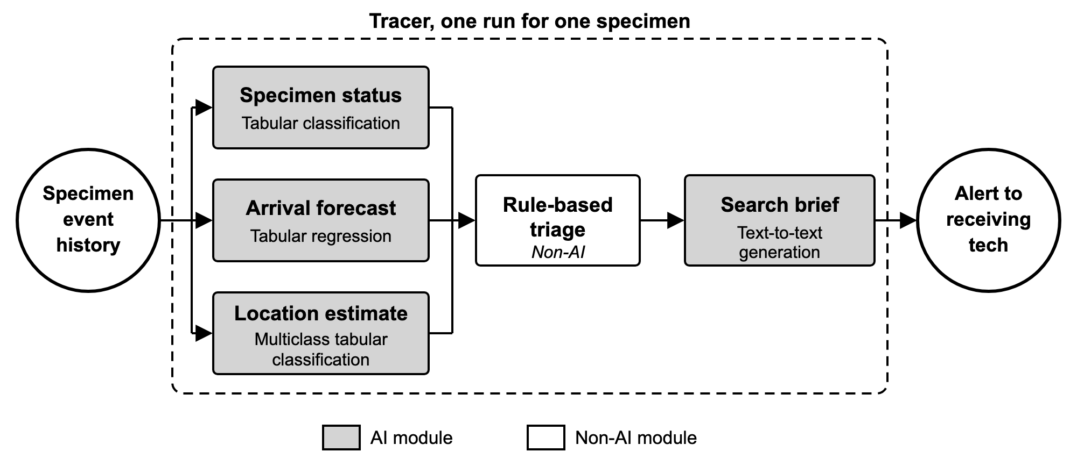
Figure 1. Single run of the deployed system for one specimen.

